ITA0305- Mobile Computing
LAB EXPERIMENT
Name: G.Ganesh
Reg NO:192373008

2. Design a user interface prototype for a mobile station using Figma, considering
connectivity and convenience.
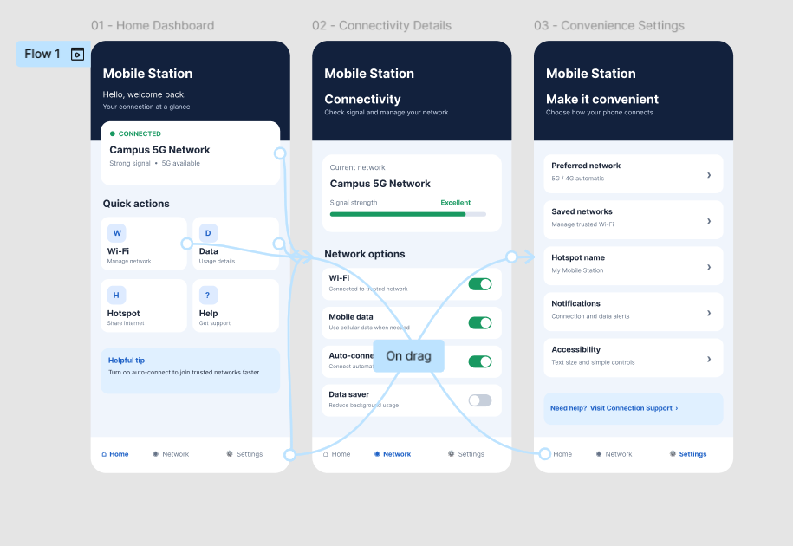

https://www.figma.com/design/EKQlKm8mkQj3Ms0OvqiSZw/Mobile-Station-UI-Prototype?node-id=0-1&p=f&t=AvW51izLjb6End2Q-0

